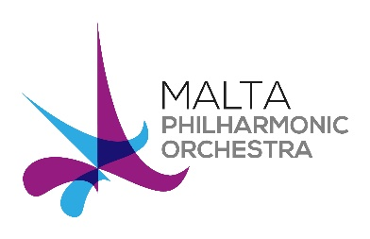 | MPO Orchestral Auditions 2019  Bassoon: Sub Principal  Audition Repertoire

Bassoon Doubling Contrabassoon when required
Round 1
With Bassoon
  - Mozart Bassoon Concerto K 191 1st and 2nd movements with cadenzas
or
  - Weber Basson Concert op.75 1st and 2nd movements

Orchestral excerpts
Excerpts:
Mozart | Le Nozze di Figaro, Overture
Verdi | I Vespri Siciliani, Sinfonia
Brahms | Variations on Haydn Theme op.56 (Var II & III)

With Contrabassoon
Bach Suite for Cello no.1 in G Major BMV 1007 Menuet I & II

Orchestral excerpts
Excerpts:
Mahler | Symphony No.4, movements I & II

Round 2
With Bassoon

Orchestral excerpts
Excerpts:
Brahms | Violin Concerto, Movement II
Ravel | Concerto in G, Presto

Sight reading

With Contrabassoon

Orchestral excerpts
Excerpts:
Beethoven | Symphony No.5, IV movement
Brahms | Variations on Haydn Theme op.56, Var IV
Ravel | Ma mère l'oye: La Belle e la Bête
Ravel | Piano Concerto for the Left Hand
Beethoven | Missa Solemnis, Gloria
Brahms | Symphony No.3, I & IV movements

Sight reading

