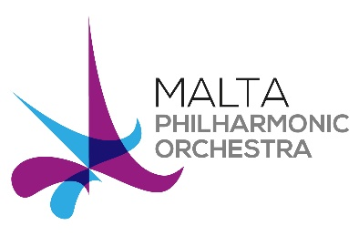 | MPO Community Orchestra Auditions 2017  APPLICATION FORM

Completed application forms need to be sent to
Arts Council Malta, 230 Casa Gaspe', Republic Street, Valletta
or email felix.galea-busuttil@artscouncilmalta.org
by no later than Monday 20th of November 2017

PERSONAL DETAILS
Kindly fill in your personal details
NAME

SURNAME

Date of Birth | / / | Age  (please note applicants must be 28yrs+)
Nationality |  | Passport / ID Card No.
Home Address
Email Address

Mobile/Telephone Number

MUSICAL EDUCATION AND EXPERIENCE

String Orchestral Instrument
How long have you been playing your instrument?
Level Achieved
(please state date, level and examining body of last practical exam, if applicable)

Other instruments you play
(please state level attained)
Theory/Musicianship Exams
(please state level attained)

Please list any orchestral or ensemble playing experience you may have.
Please provide any additional information that is relevant to your application, such as details of any musical performances, masterclasses and/or competitions.

Briefly, tell us why would you like to join the Malta Community Orchestra?
What piece(s) would you like to perform for your audition?
MUSIC REFEREE  (optional) | Name:  Position:  Tel/Email:

Signature: ________________________ Date: _____________

