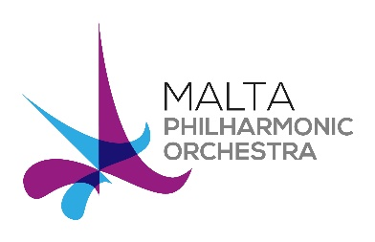 | MPO Orchestral Auditions 2016  Musicians’ Application Form

Instrument
Position applied for

PERSONAL DETAILS
Kindly fill in your personal details in BLOCK LETTERS

Surname

Name(s)

Date of Birth | / / | Gender | Male/Female
Nationality |  | Passport / ID Card No
Residential Address
Email Address

Telephone Number

Completed application forms, together with supporting material must reach the MPO offices by no later than 12:00 noon on Monday 4th of April 2016.

MUSICAL TRAINING AND EXPERIENCE
Kindly use the space provided or add additional sheets if necessary
Please list details of your orchestral experience, starting with your most recent.

Please list your musical education and training, including name of institution and/or teachers, courses followed, dates and qualifications obtained.
ADDITIONAL INFORMATION
Kindly use the space provided for the suggested additional information
Please provide any additional information that is relevant to your application, such as details of solo/chamber music performance, masterclasses and competitions.

Please give a brief explanation of why you would like to join the Malta Philharmonic Orchestra

AUDITION PIECES
Kindly indicate the selected pieces (from the list provided on our website) that you will be performing in this audition.
Round 1 | Round 2
REFERENCES
Please list at least two referees, including their email addresses
Name:  Position:  Email: | Name:  Position:  Email:

SUPPORTING MATERIAL
You are kindly requested to support your application with the following material
Material/Document |  |  | Attached/Linked
1. | Detailed Curriculum Vitae
2. | Copies of Relevant Qualifications
3. | Recent video recording of your own performance  You may send us your recording via bulk transfer, or provide links to YouTube. Please provide details of recording and mode of transfer below.  Recording:  Data Sent Via:
Signature |  | Date
For Office Use Only

